
Lesson 15 Teacher's Key: Ready to Show
Scratch - Instructor Reference Only
VIDEO GAME CREATION

How This Key Is Different Today
There's no new Level 1 solution to give this week - Lesson 15 is a polish-and-present day, not a new-mechanic day. This Key instead consolidates the most common last-mile issues seen across this engine's Lessons 2-14, to help you diagnose a stuck student quickly during polish time.
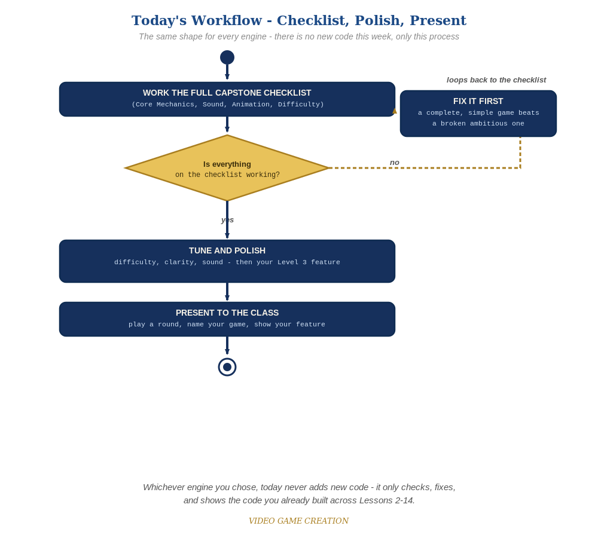
Today never adds new code - the same checklist-polish-present loop applies no matter which engine you chose.

Known Recurring Quirks in This Engine
- Variables scoped to one sprite instead of "for all sprites," so a value looks right on one sprite's script but reads as 0/default elsewhere.
- A broadcast script ("when I receive [x]") accidentally left off the sprite it needs to be on, especially after copy-pasting scripts between sprites.
- A costume/graphic effect (from Lesson 13's flash) left set to a nonzero value after a clone is deleted, which can bleed into a freshly-cloned enemy if not reset in the spawn script.

Fast Diagnostic Questions
- "Is this variable 'for all sprites' or 'for this sprite only'?" - the single most common root cause of confusing behavior in Scratch by this point in the course.
- "Which script actually broadcasts this, and which sprite is listening for it?" - broadcast bugs are almost always a mismatch here.

If a Student Is Significantly Behind
Prioritize getting Lessons 6-11's Level 1 (win/lose, restart, multiple waves) solidly working before anything from Lessons 12-14 - a complete, simple game presents better than a broken ambitious one.

Presentation Day Notes
- Scratch's stage view makes for an easy, quick demo - no special setup needed beyond having the project open and the green flag ready.

